INDEX
A) PHASE-1
1) Once the necessary folders that are received
2) First Create a Folder with Current Date on your local PC.
3) Create 4 Folders inside it
3.1) Server
3.2) Register
3.3) Testing
3.4) Database
B) PHASE-2
1) Login into VCDeploy: Sign in – VCDeploy
2) Create a new Client in it.
3) Verify Client name
4) Client Version
5) Version Number
6) Upload the Deployment Package
C) PHASE-3
1) Take the Remote Access of the Server.
2) Go to the Folder
3) Open the Config File
3.1) Services.msc
3.2) Config.json File
3.3) Task Scheduler
4) Open CMD
5) The Auto – Deployment will Start successfully.
6) Quick access links
7) THE END
BASICS
What is Auto-Deployment?
Auto-Deployment is a process used to deploy software updates to a target server in a controlled and automated manner.
Why are we doing Auto-Deployment?
The main purpose is to deploy a software update without manually performing every individual operation on the server.
What does the Auto-Deployment process involve?
- Preparing the deployment package
- Configuring the required Client and Version in VCDeploy
- Uploading the deployment package
- Configuring the target server
- Executing the deployment
AUTO-DEPLOYMENT PROCESS
PHASE - 1
1) Receive the required patch folders.
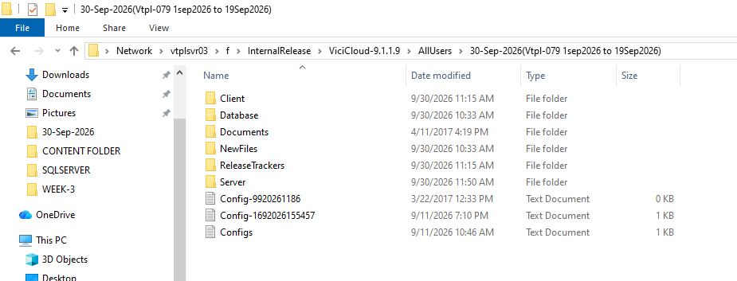
Once the required patch folders are received, begin the Auto-Deployment preparation process.

2) Create a new folder on the local PC using the current date.
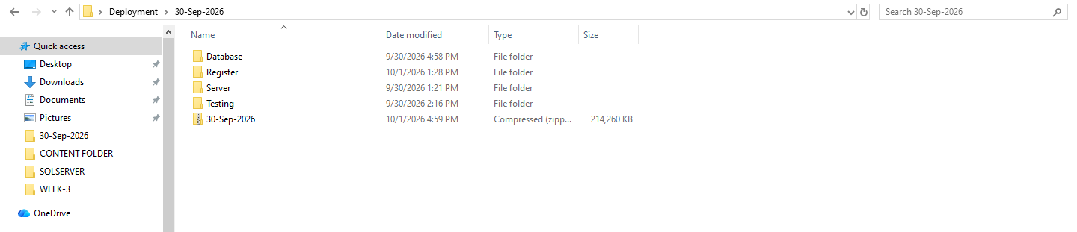
- The Folder format should be DD-MMM-YYYY
Example - 14 – Sep – 2026
20 – Oct – 2026
Month should be written in a 3 – letter Format in the Folder-name.
3) Create the required folders
3.1) Server - The received patch contains a folder named Server.
Copy the required contents from the patch Server folder into the locally created Server folder.
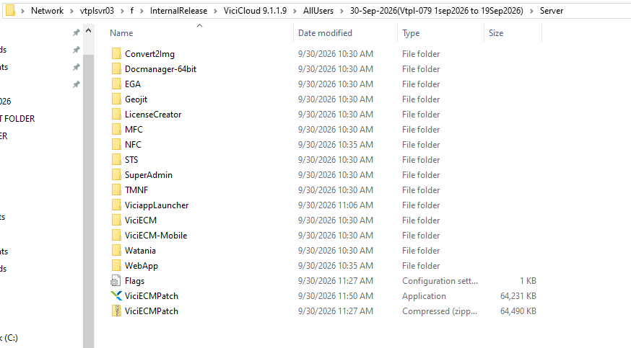
Note:
3.1.1) Copy all the folders present in the Server folder.
3.1.2) Do not copy the following:
- Flags
- ViciECMPatch
- ViciECMPatch.zip
These files/folders must not be included in the deployment package.
3.2) Register – The Register folder must contain the required Register and Unregister batch files.
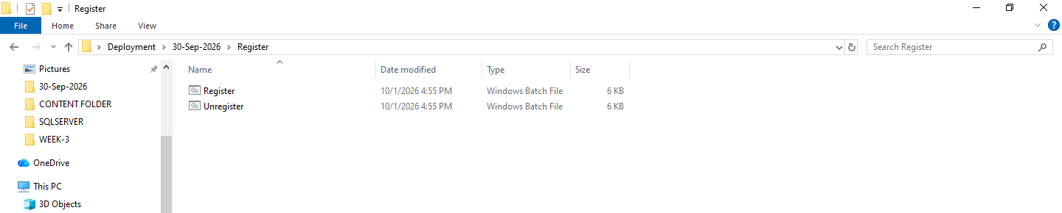
------------------------------
3.3) Testing – If we are going to run Performance and Functionality Tests, we need to include these two folders – Performance and Functionality.
- Required only if performance or functionality testing is enabled - Must contain `Performance/` and / or `Functionality/` subfolders.
- ZIP files must be named exactly as specified in `config.json`: - `Results_Performance.zip`
- `Results_Functionality.zip`
Testing Folder is Optional.
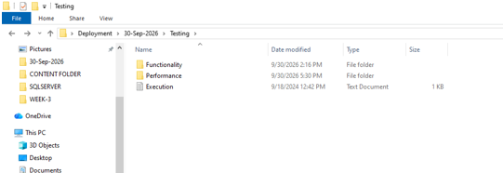
3.4) Database – The Database folder must contain the required SQL deployment and rollback scripts, if provided.
First, identify whether the repository is connected to:
- SQL Server
- Oracle Server
For each applicable database type, both Deploy and Rollback scripts are required.
Take the required scripts from the Patch folder.
SQL Server
The expected naming convention is:
Sql_Rep_Deploy.sql
Sql_Rep_Rollback.sql
Sql_Rp_Deploy.sql
Sql_Rp_Rollback.sql
Oracle
The expected naming convention is:
Ora_Rep_Deploy.sql
Ora_Rep_Rollback.sql
Ora_Rp_Deploy.sql
Ora_Rp_Rollback.sql
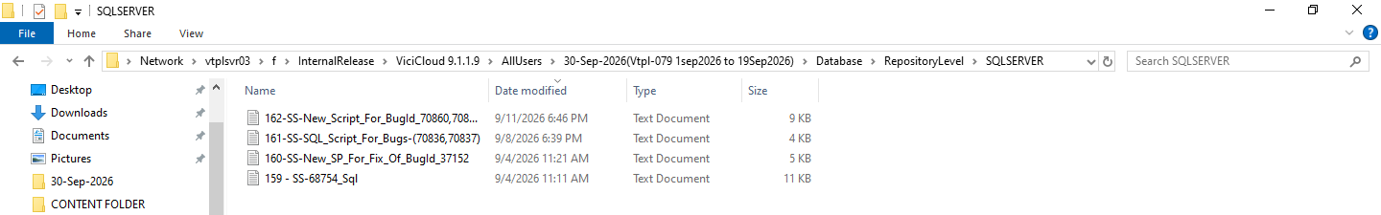
Consolidating SQL Deployment Scripts
In our case, four .txt files containing SQL database deployment scripts were provided.
To consolidate these scripts into a single SQL deployment file:
- Create a new blank text file on the local PC.
- Copy and paste the contents of all four .txt files into the new file in the Local PC. Don’t Disturb the files in any way in the given Network Path.
- Select File → Save As.
- Select All Files as the file type.
- Change the file extension from .txt to .sql.
- Save the consolidated file as:
Sql_Rep_Deploy.sql
This consolidates the four separate .txt files into a single SQL deployment script. Do the same Consolidation Process for Rollback file if needed.
Important: Do not provide four separate files for Rep_Deploy and another four separate files for Rep_Rollback. The scripts must be consolidated according to the required naming convention.
This completes the Folder Creation Process.
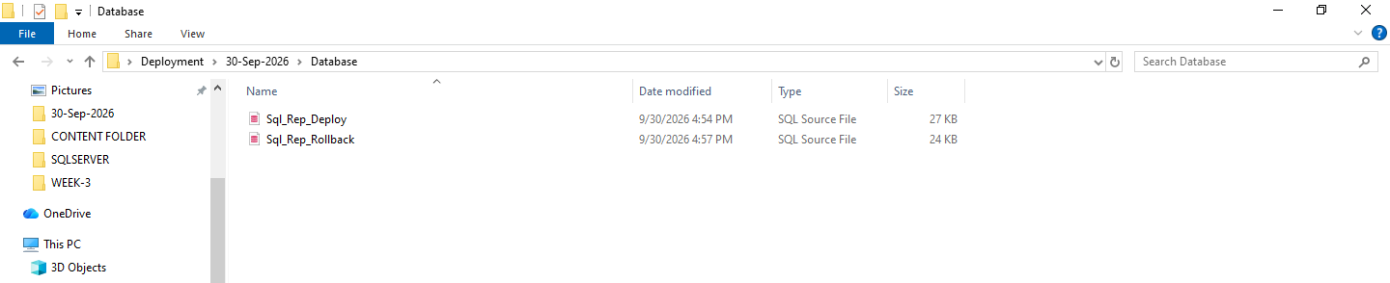
PHASE-2
1) Login into VCDeploy: Sign in – VCDeploy
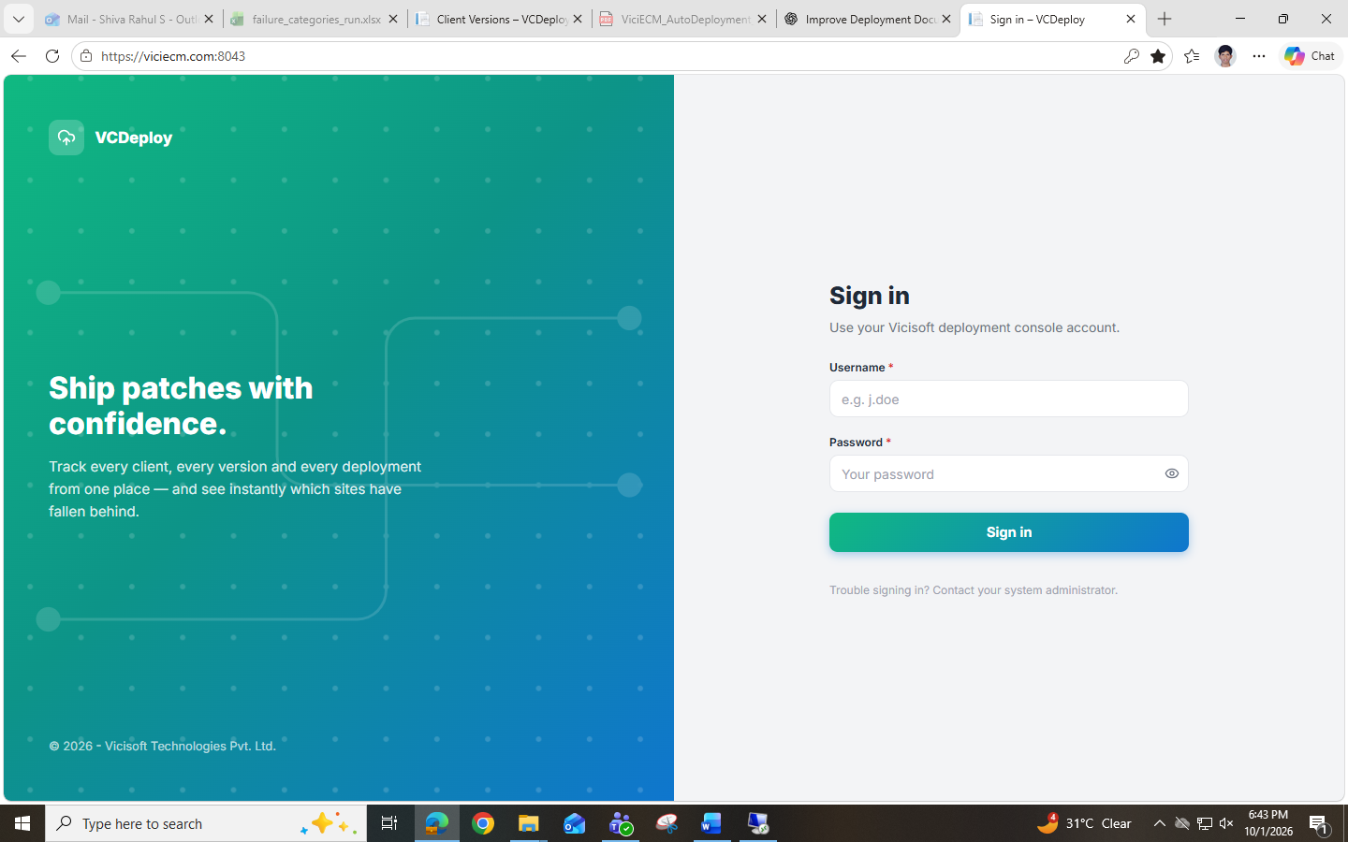
2) Create a new Client.
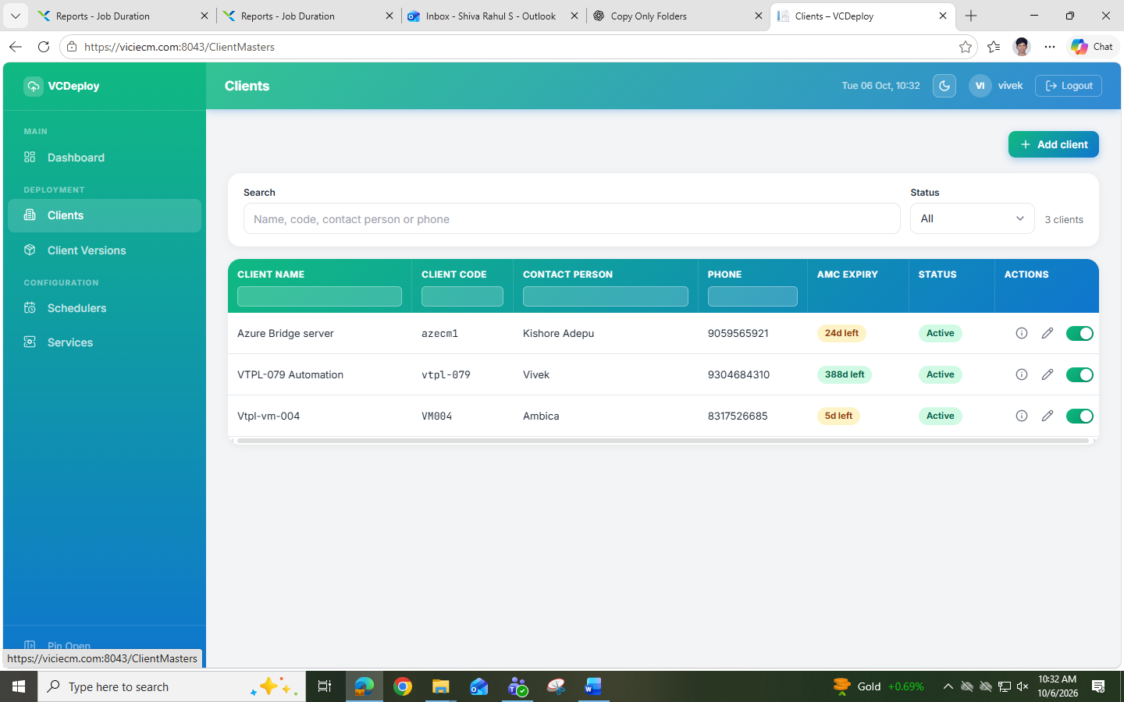
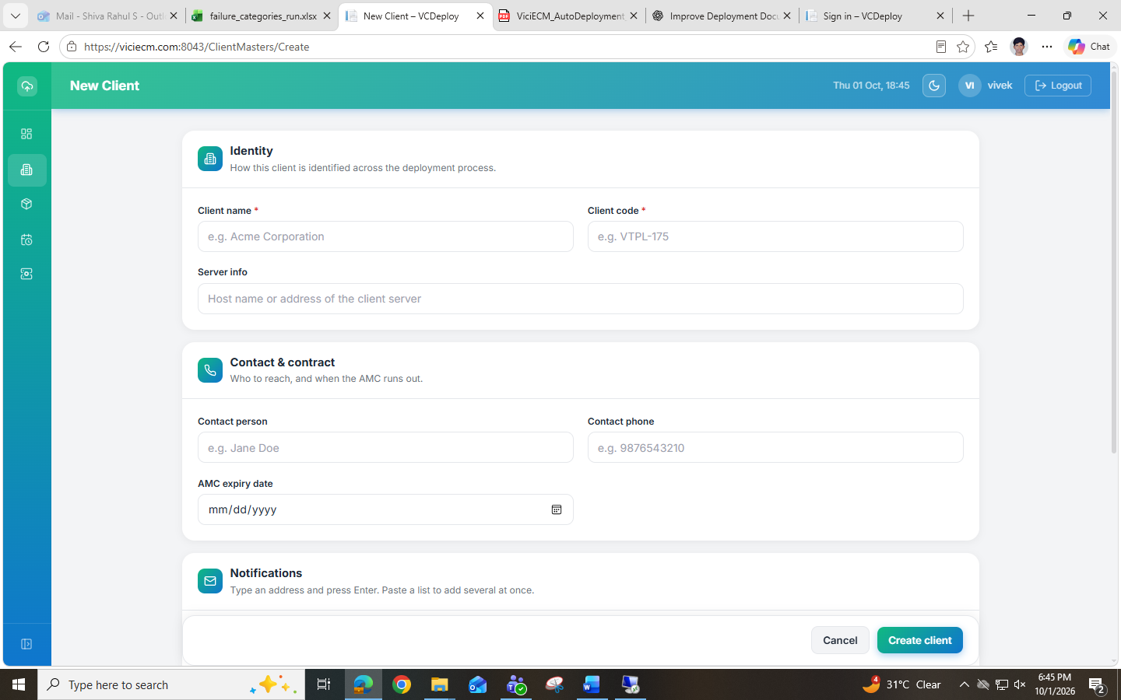
3) After successfully creating the Client, verify that the Client Name is displayed in the Client List.
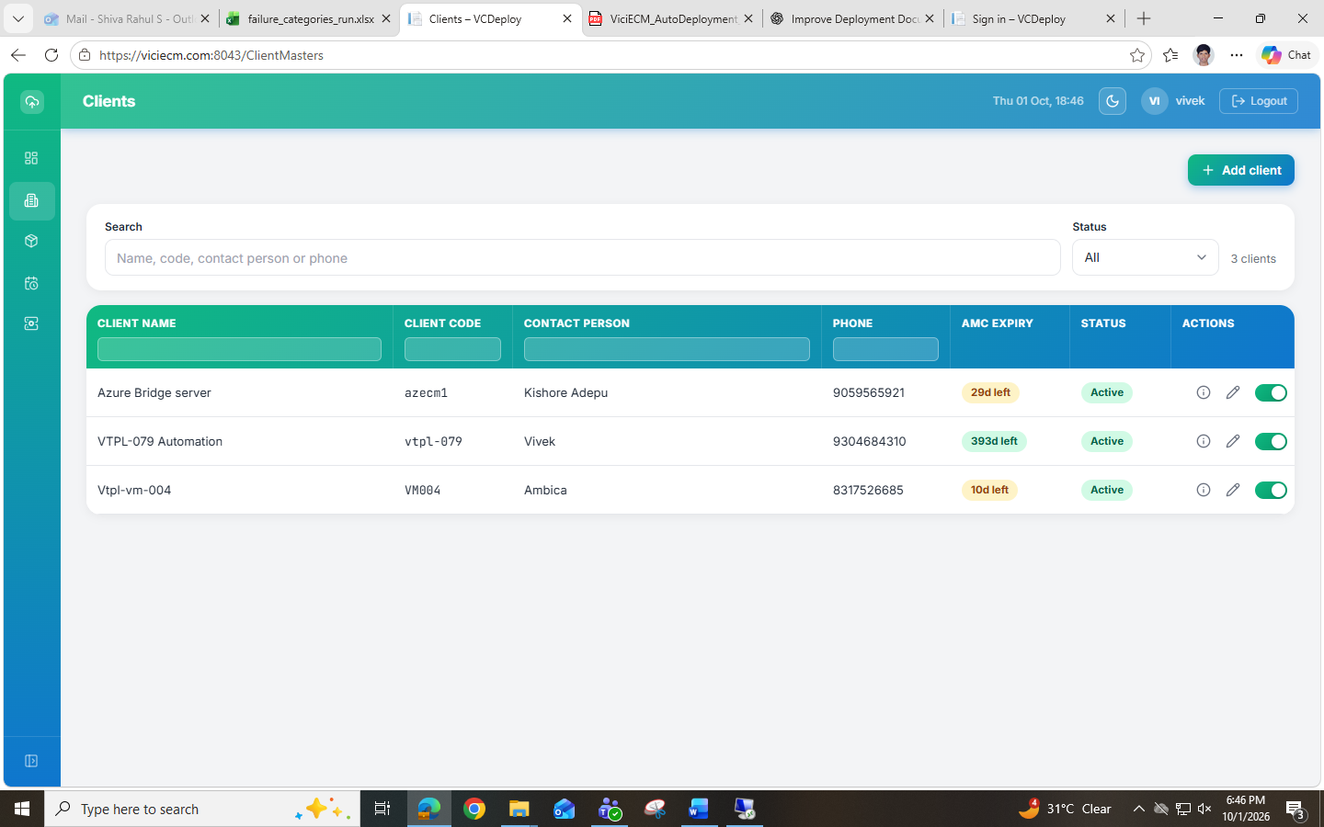
4) From the sidebar, select:
Client Version → Click on Edit → Select the Created Client
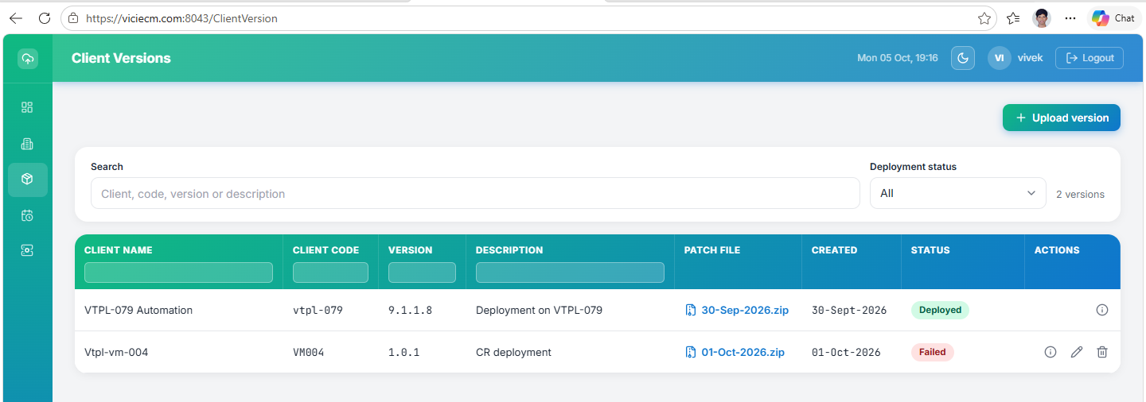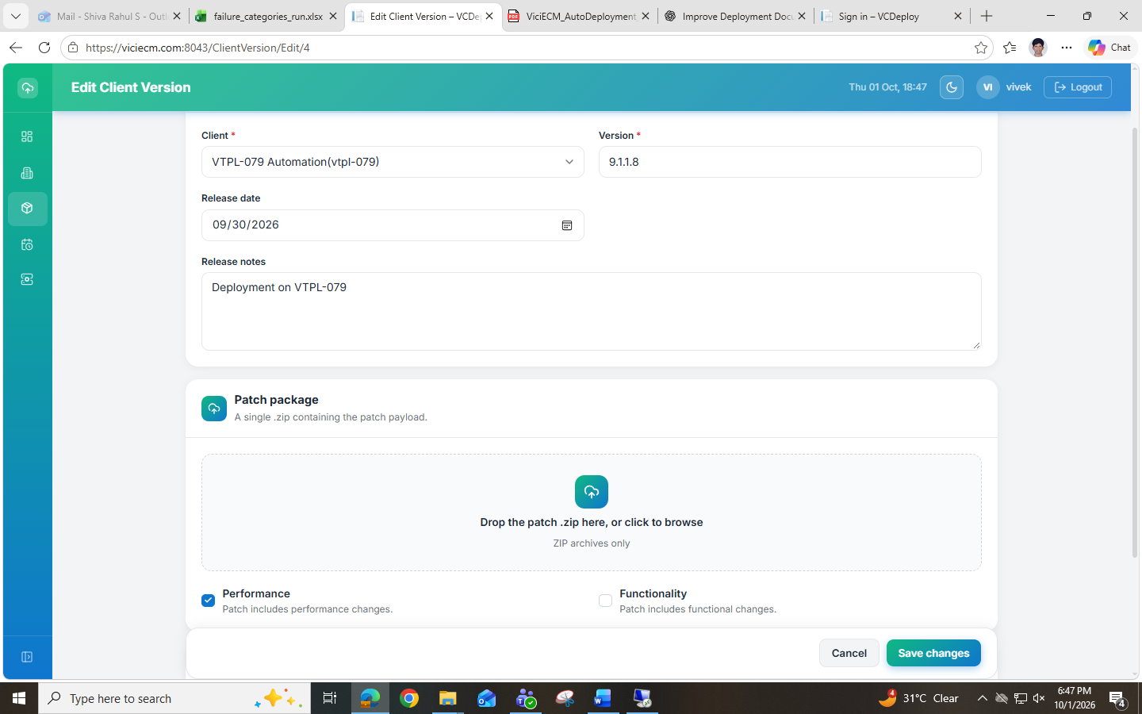

5) Identify the Version Number
5.1) Open the Vici_Autodeployment Folder in VTPL-079
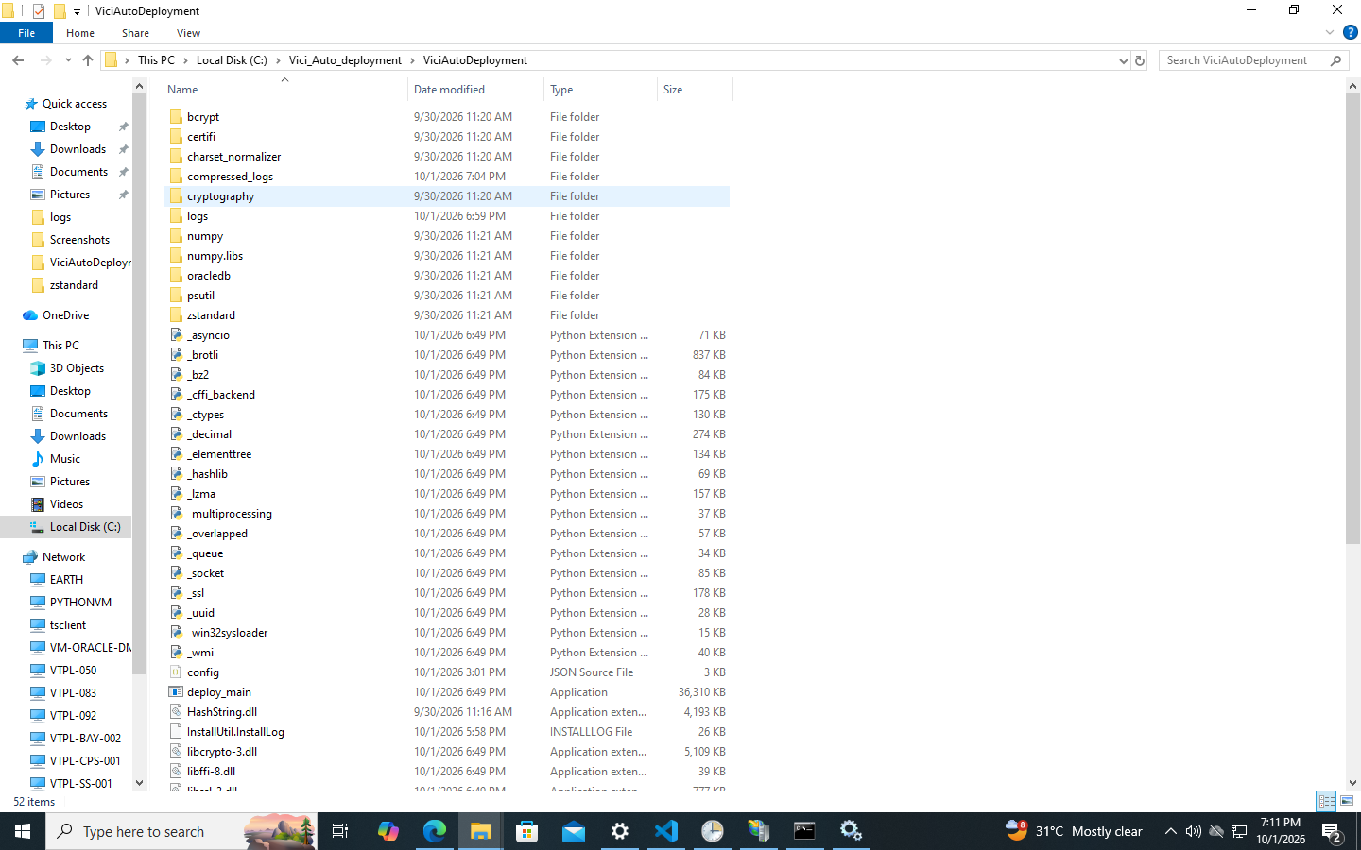
5.2) Open the Config file and locate the Reg_Key_path.
Open Registry Editor and navigate to the specified registry path.
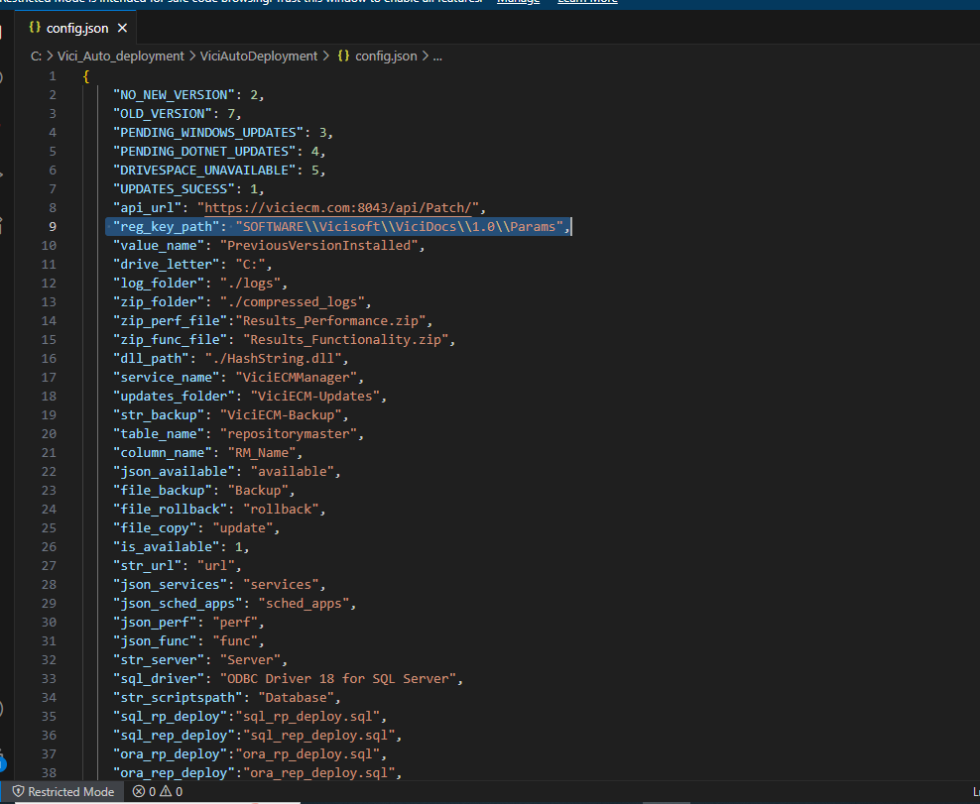
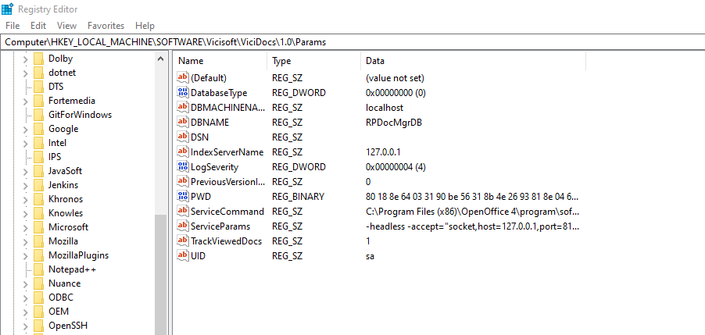
5.3) Check the value of PreviousVersionInstalled.
Check the currently installed version.
Example:
If the current version is:
9.1.1.2
enter the next version number 9.1.1.3 in VCDeploy.

6) Upload the Prepared Folder (30-Sep-2026.zip)
Upload the ZIP file containing the four folders created during the Folder Creation Process into VCDeploy.
Click Save Changes.
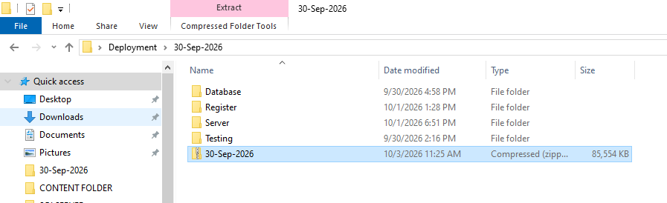
After saving the changes, verify that the Client status is displayed as:
Ready to Deploy
Important: Proceed to Phase 3 only after the status is confirmed as Ready to Deploy.
PHASE-3
1) Take the Remote Access of the Server.
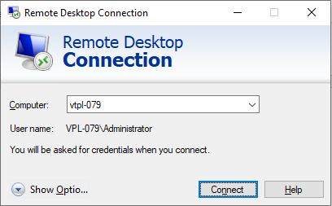
2) Navigate To : C:\ Vici_Autodeployment Folder.
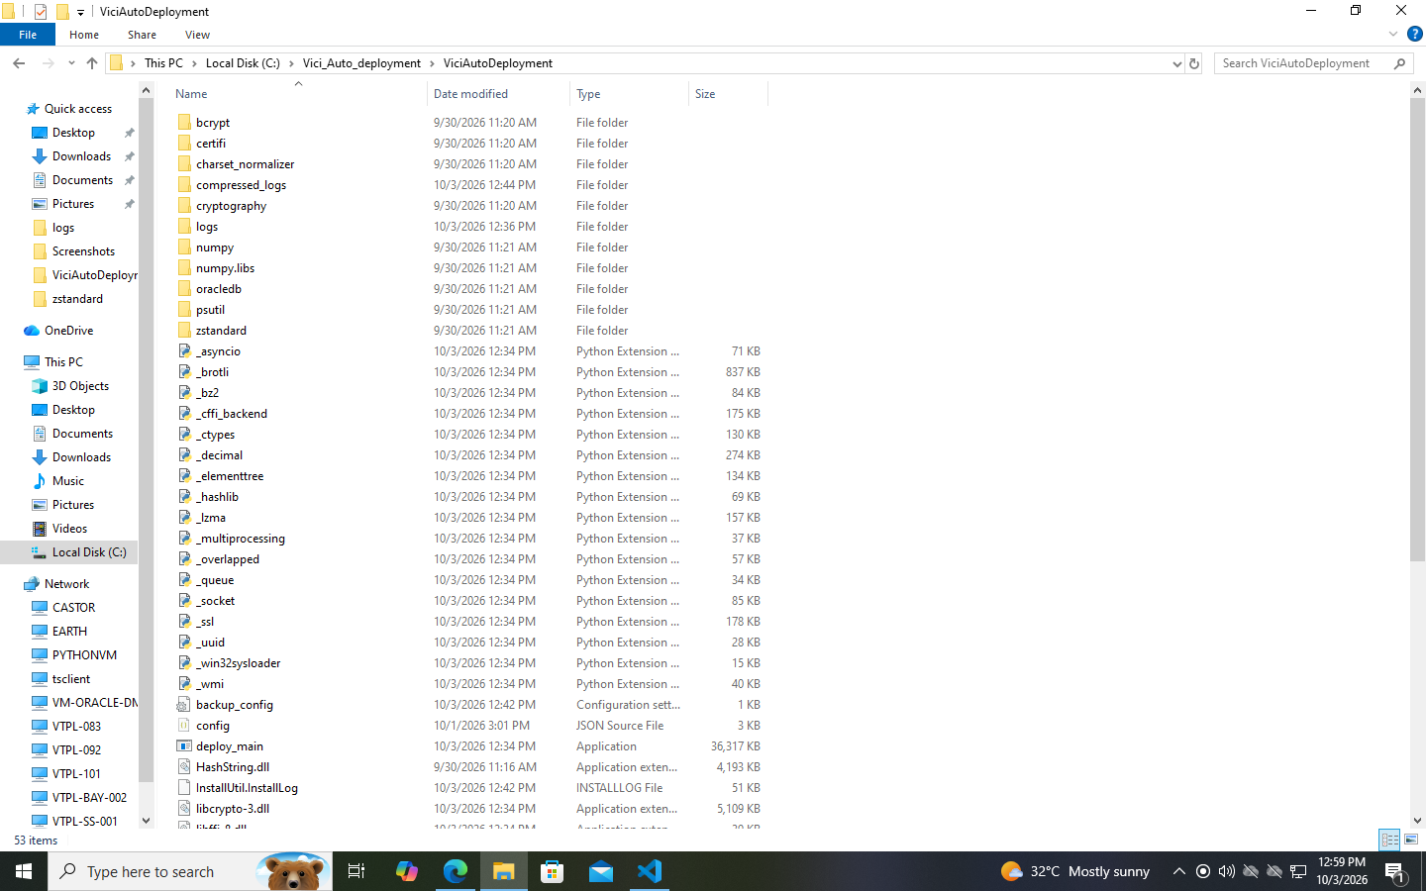
3) Open the Config file and navigate to the bottom of the configuration.
Configure the required Services and Task Scheduler entries in the Config.json file.
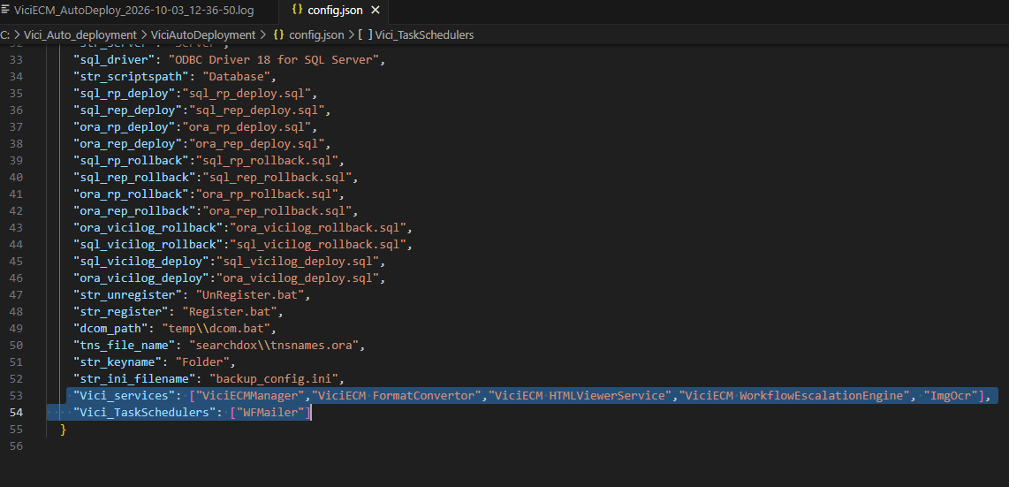
3.1) Open the Services Window by pressing Win + R, enter Services.msc
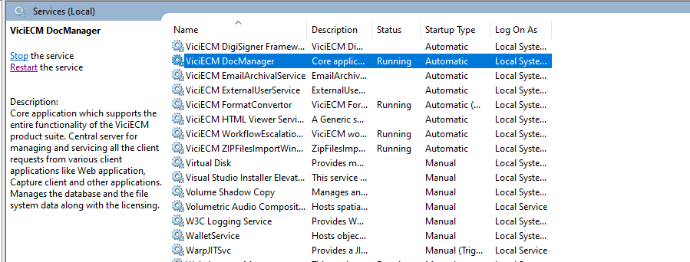
3.2) Copy the Service names of the Following list which are relevant and put them into the Config.json File accordingly.
3.3) Open Task Scheduler and Copy the name of the different Services. The task should be related to the VTPL-079 Server and then the status should also be Ready.
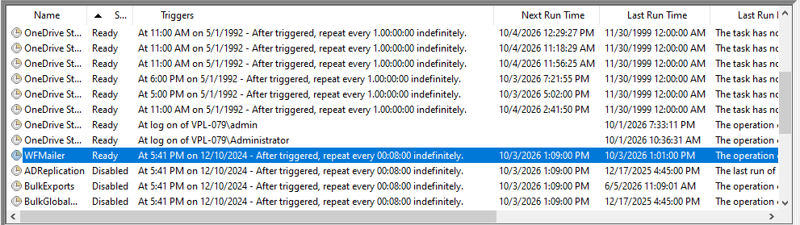
Note: Do not copy the name of the tasks which have status as Disabled.
And, if None of the Tasks are in the Ready Status then just enable any one service and update it in the config file.
4) Open CMD as an Administrator.
4.1) In CMD, enter:
cd <File path of Vici_Autodeployment folder>
Press ENTER.
4.2) Type:
Deploy_main.exe vtpl-079
Press ENTER.
Note: Type DEPLO and press TAB to auto-fill Deploy_main.exe.
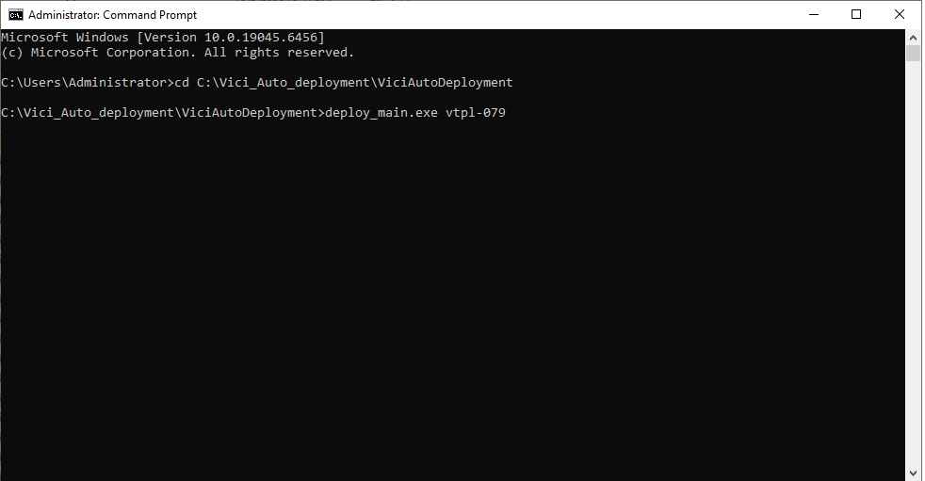
5) The Auto – Deployment will Start successfully.
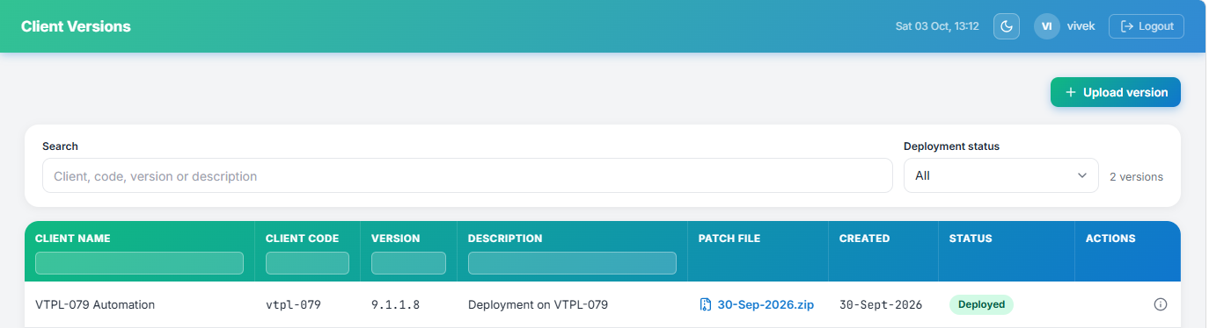
If the deployment fails, the system will automatically perform a rollback using the rollback scripts provided in the deployment package.
If the deployment needs to be attempted again:
- Make the necessary corrections based on the deployment failure.
- Return to VCDeploy.
- Refresh the Client Version page.
- If required, upload the updated deployment package.
- Click Save Changes.
- Verify that the status is displayed as Ready to Deploy.
- Proceed with the deployment again.
EXAMPLE OF A FAILED DEPLOYMENT MAIL:
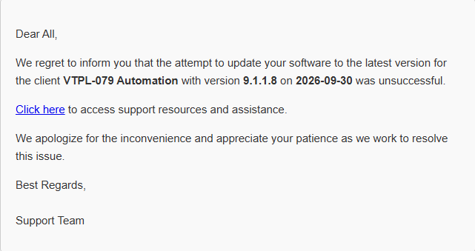
EXAMPLE OF A SUCCESSFUL DEPLOYMENT MAIL :
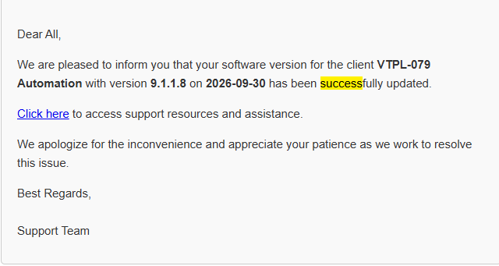
Quick Access Links: C:\Vici_Auto_deployment\ViciAutoDeployment
\\vtplsvr03\f\InternalRelease\ViciCloud 9.1.1.9\
Sign in – VCDeploy

THE END

